How to calibrate your monitor

Wednesday, July 18, 2018

12:49 PM

**How to calibrate your monitor**

**Calibrate your display to get it looking just how you like it**

By [**Jon Martindale**](https://www.digitaltrends.com/users/jonmartindale/) — Posted on July 13, 2018 - 5:00PM

Plenty of people stare at computer monitors all day — if you’re reading this, chances are you’re doing just that. But how many people take the time to calibrate their [computer monitor](https://www.digitaltrends.com/computing/best-computer-monitors/)? Proper calibration will ensure that your colors and black levels are true, and that your monitor is producing the best results for editing and viewing images and videos. Plus, it will be easier on your eyes!

You could take your monitor to a professional to have it done, but doing it yourself is relatively quick, hassle-free, and will greatly improve image quality. [Manufacturers keep pumping out](https://www.digitaltrends.com/computing/displays-continue-to-improve-with-hdr-and-4k-at-ces-2017/) displays with new technologies like 4K UHD resolution, [high-dynamic range (HDR)](https://www.digitaltrends.com/home-theater/what-is-hdr-tv/), and [curved monitors,](https://www.digitaltrends.com/computing/best-ultra-wide-monitors/) providing a veritable feast for the eyes — but only if they are properly calibrated.

BEFORE YOU BEGIN

You’re going to want to do several things before you begin the calibration process. These steps aren’t absolutely mandatory, but they’re good to follow for best results.

* + Turn on your monitor at least a half hour before calibration so it can warm up to its normal operating temperature and conditions.
  + Set your monitor’s resolution to its native, default screen resolution.
  + Make sure you’re calibrating in a room with moderate ambient lighting. The room doesn’t need to be pitch black, but you don’t want the sharp glares and color casts resulting from direct light.
  + Familiarize yourself with your monitor’s display controls. They may be located on the monitor itself, on the keyboard, or within the operating system control panel.

**CALIBRATE USING BUILT-IN WINDOWS**

Both MacOS and Windows have built-in calibration tools to help guide you step-by-step through the process, which is particularly helpful if you are new to monitor calibration. These free tools should be the first stop if you’re merely a casual image junkie or working on a tight budget. Keep in mind that the adjustments will be limited by the display type and model, though.

The assorted terms — gamma, white point, etc. — may seem a bit daunting at first glance, but each utility provides a relatively simple explanation of what they all mean. Realistically, you don’t need to know the ins and outs of the jargon to calibrate your monitor.

**Windows 10 display calibration tool**

In the [latest version of Windows 10](https://www.digitaltrends.com/computing/windows-10-april-2018-update-what-you-need-to-know/), the easiest way to find the color calibration tool is through the Windows search bar.

**Step 1:** Type “Color Calibration” into the Window search bar, and click the corresponding result.

In older versions of Windows, you can find the Color Calibration utility in the Display section of the Control Panel, which is listed under “Appearance and Personalization.”

[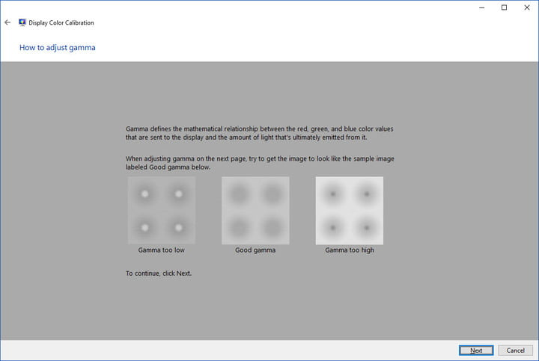](http://s3.amazonaws.com/digitaltrends-uploads-prod/2017/07/Windows-10-Display-Color-Calibration-Tool.jpg)

Mark Coppock/Digital Trends

**Step 2:** Now that you are in the calibration tool, follow the on-screen instructions to choose your display’s gamma, brightness, contrast, and color balance settings.

A sample image for you to match will accompany many of the settings. Simply make adjustments to mimic the sample as close as possible.

**Step 3:** Once the calibration wizard is complete, make sure to choose the “current calibration,” or return to the previous calibration if you are unsatisfied with the results.

The new calibration will be stored as a .ics file, or color calibration file, and will show up as a new International Color Consortium (ICC) Profile in the Color Management settings app. The easiest way to open this app is to type “color management” in the search box and choose the first result. Once it’s open, you can select your monitor from the device list and see which ICC Profiles are available.

[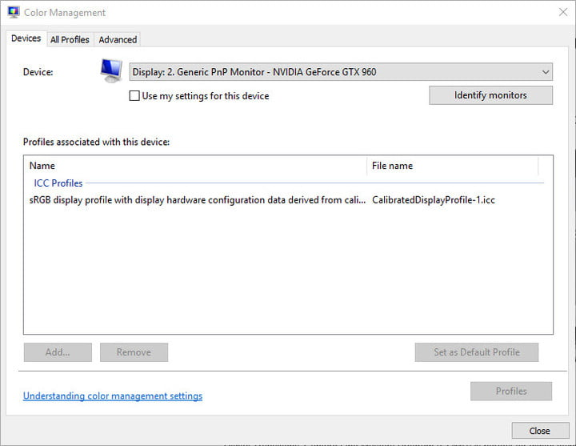](https://icdn4.digitaltrends.com/image/windows-10-color-management-icc-profile-726x562.jpg)

Mark Coppock/Digital Trends

Pasted from <<https://www.digitaltrends.com/computing/how-to-calibrate-your-monitor/>>